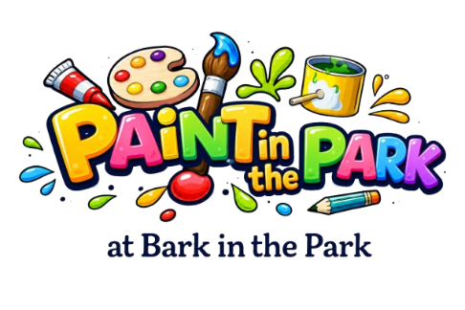
PAINT IN THE PARK
SUNDAY AUGUST 23
REGISTRATION
Personal Details
Name
Email
Tel
Please Tick
Adult Artist
Junior Artist
(under 16)
Likely Subject
The Scene
Pet Portrait
Information
- Registration Fee is £8 (supporting The Lexi May Trust from profits)
- A blank canvas is required at registration
- Paintings of the scene or a chosen dog or dogs can be submitted for judging
- Consider offering a dog portrait to any dog owner for funds to support The Lexi May Trust
- Registration opens from 10am
- Bacs payment for registration fee to
- Art at the Duchess 60 07 01 Account 47214325
- Return form to david@artattheduchess.com

SIGNED………………………………………………………………………..

Registration payment £8 made.

